Horton’s: We Have Food for Your Mood

You often hear people say “I’m hungry but I don’t know what I’m in the mood for.” As humans, we have the ability to create variety in the things we consume, and it’s awesome! Believe it or not, our mood can affect the type of food that sounds good to us. Horton’s Pizza Plus has studied this and we believe that our menu can serve every mood you may find yourself to be in!

Go Big, Not Home

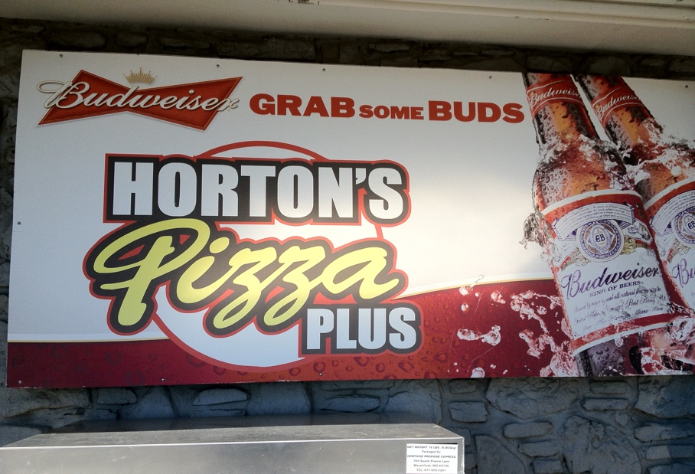
Nothing builds up an appetite quite like a long, fun day of enjoying the outdoors with friends and family. Plus, with the high percentage that some type of sporting event will be on TV tonight, there’s no way that a regular old meal is going to cut it. You need something big, something real. Well, the answer is the Sink pizza at Horton’s Pizza Plus. This made-from-scratch pie has a variety of meats packed into it including beef, sausage, Canadian bacon, peperoni, Italian sausage, and bacon. If that doesn’t make your taste buds water, then try adding green pepper, black olives, mushrooms, and some glorious pineapple to it. This pizza is enough to fulfill even the biggest of appetites.

Light and Real

Horton’s Pizza Plus does not just specialize in pizza, we take pride in a variety of American classics, including our indulgent salads. If you’re feeling something light for dinner, then our chicken salad is the way to go. This specialty is tossed with chicken, veggies, two extra meat choices all on top of a heavenly bed of lettuce. Add some of our amazing garlic ranch dressing, and you’ve got quite the delectable meal.

Something from Home

If you’re finding yourself in the mood for something you don’t see every day, then our homemade meatballs are the answer. Horton’s Meatballs will give you the feeling of having a home-cooked meal, except better! Served with Horton’s specialty pizza sauce and loaded with cheese, you simply can’t go wrong.

Total Domination

Are you in a mood filled with adrenaline and a “let’s crush it” mentality? These usually take place right before watching a big game on TV, and there’s nothing more suiting for the occasion than Horton’s hot wings. Served in a variety of sizes, these bone-in and boneless wings are no joke. With the options of ranch, BBQ, Frank’s red hot, or blue cheese, these wings are sure to satisfy your mood.

The next time you’re finding yourself in the mood for food but not sure what it is exactly that sounds good, head on over to our website, www.hortonspizzaplus.com and look at a menu. We promise you’ll find something suiting to your appetite! With locations in Joplin, Pittsburg, Parsons, there’s always a Horton’s close to you!

